Assalam o Alaikum
This is a small turorial to add a helloworld System call in Linux.
here I used linux kernel version 3.16.0 couple of years ago.
Hint : use stable version of kernel for this task.
Open the terminal

*Note ignore the inverted commas while copying.
*Note where I write do not copy the line than write it by yourself to avoid bugs

First download the linux-3.16 kernel version
Copy paste following line to the terminal
wget https://www.kernel.org/pub/linux/kernel/v3.x/linux-3.16.tar.xz
This line will start downloading the linux-3.16
we use wget command to download direct files from website
after downloading the linux kernel version
open the terminal type
sudo -s
to make it root
go to download folder as the file is present in download folder
cd Downloads
after this type the following line to extract it to c/usr/src/
sudo tar -xvf linux-3.16.tar.xz -C/usr/src/
sudo – to gain root access.
tar – Tar stores and extracts files from a tape or disk archive.
-x – extract files from an archive
-v – requested using the –verbose option, when extracting archives
-f – –file archive; use archive file or device archive
-C, –directory DIR,change to directory DIR( here to change to /usr/src/)
After extracting the file type this line in terminal “cd /usr/src/linux-3.16/”
than make file in it named hello “mkdir hello”
go to the folder hello “cd hello”
after this make .c file in the hello file “gedit hello.c”
write the following lines in the hello.c file
I advice you to not copy and paste these lines in hello.c , type it by yourself
“#include <linux/kernel.h>
asmlinkage long sys_hello(void)
{
printk(“Hello world\n”);
return 0;
}
”
After this create makefile in the hello file “cd /usr/src/linux-3.16/hello/”
write the following in the terminal
“gedit Makefile”
a file open in front of you on notepad type the following line in it “obj-y := hello.o”
*remove the inverted commas while copying this line to file
Now go to the linux-3.16 folder again by copying “cd /usr/src/linux-3.16/”
now open the file named Makefile “gedit Makefile”
goto line number 842 which says :- “core-y += kernel/ mm/ fs/ ipc/ security/ crypto/ block/ ”
change this to “core-y += kernel/ mm/ fs/ ipc/ security/ crypto/ block/ hello/”

now after doing this now you have to enter your system call number which you have added in it if you are in linux-3.16 folder than copy this line “cd /arch/x86/syscalls/”
other wise copy this “cd /usr/src/linux-3.16/arch/x86/syscalls/” and paste it on your terminal
*Note to see whether your system is 64 bit or 32 bit goto search type system and goto “system settings”
and in this select the 3rd last option named “Detail”
now if you have 32 bit system than do the following
gedit syscall_32.tbl
add the following line in the end of the file :-
354 i386 hello sys_hello
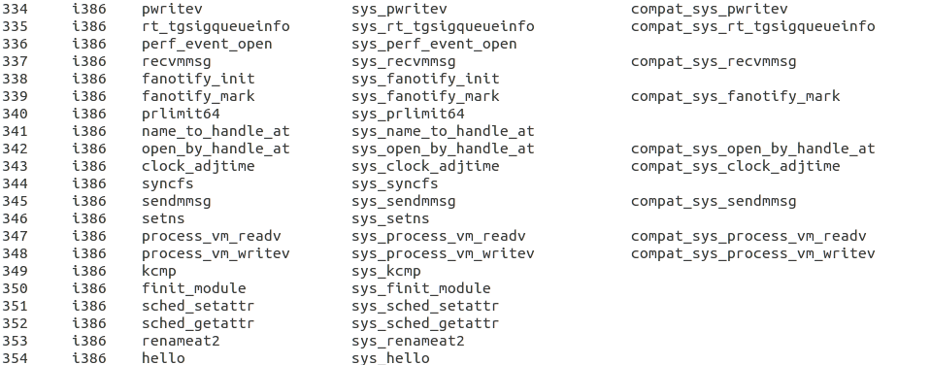
*Note 354 is the increment of the last system call number watch this screen shot
For 64 bit do the following
gedit syscall_64.tbl
add the following line in the end of the file :-
547 common hello sys_hello
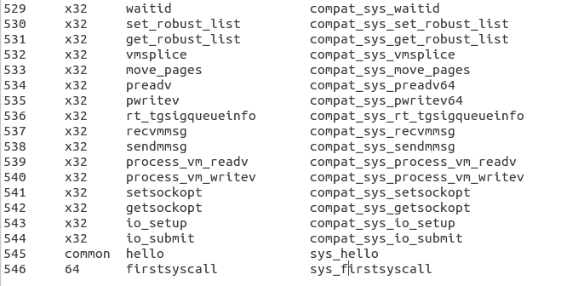
*Note watch this screen shot
in this I have added it at 545 no because when I started to compile my kernel 544 is the last system call no and you will have to use the number which is the increment of the last system call no
like 547
After doing this add your system call name in the system call header file
for this tydpe “cd ” in the terminal and than copy the following line
“cd /usr/src/linux-3.16/include/linux/”
than type “gedit syscalls.h”
in this type the following line in the file . Avoid copying it
*Note type this line at the end of the line before #endif statement
“asmlinkage long sys_hello(void);”
After this if you want to configure your kernal by using “make menuconfig” or “sudo make menuconfig” first you have to install all packages by typing following statements on your terminal
1.sudo apt-get install gcc
2.sudo apt-get install libncurses5-dev
3.sudo apt-get update
4.sudo apt-get upgrade
after this goto “cd /usr/src/linux-3.16/”
type “Sudo -s”
than type “make menuconfig” or “sudo make menuconfig”
a pop up window came up in front of you
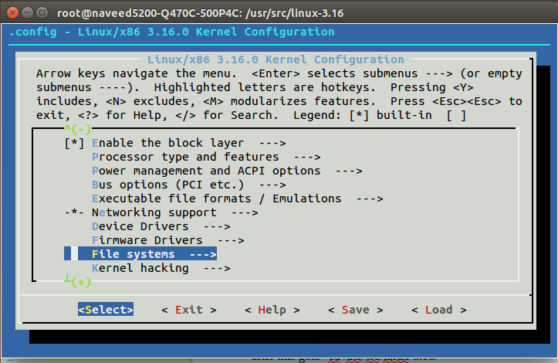
In this you have to select “file systems” after this new pop up window will open and in this you have select all the lines which have ext4 in it.
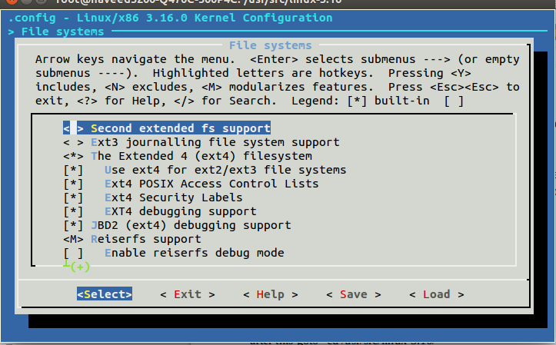
After this you exit that pop up window now goto “cd /usr/src/linux-3.16/”
write “make” to compile the kernel after 2hrs or 2hrs 10mins it will compiled now reboot your computer
To install /update the kernel.
To install this edited kernel run the following command:-
sudo make modules_install install

*NOTE
AFTER REBOOTING While you are in the menu where you select “ubuntu” you should have to select “Advanced options for ubuntu” then
Select your kernel version which you have install on your ubuntu like I install “linux-3.16.0”
so in that menu “linux-3.16.0” is present and I'll select it and after this ubuntu will automatically start don't worry
open the notepad and write the following in it

//test.c
#include <stdio.h>
#include <linux/kernel.h>
#include <sys/syscall.h>
#include <unistd.h>
int main()
{

long int check = syscall(545); // I have write my system call no , write your own
if(check==0)
printf("\nHi, call is working\n");
else
printf("\nCall is not working\n");
return 0;
}
and compile it on the terminal by writing “gcc test.c” and open it .exe on terminal by writing this “./a.out” on the terminal
if it prints “hi call is working” than mission is successful otherwise try again... by reading again that file
if you want to see message on kernel log type “dmesg”

References
1.https://tssurya.wordpress.com/2014/08/19/adding-a-hello-world-system-call-to-linux-kernel-3-16-0/
2.http://stackoverflow.com/questions/26720644/adding-new-system-call-to-linux-kernel-3-13-on-64-bit-system
* Open the references if something you don't get or contact me .
Regards
Dr Nabeel Sabir Khan

